**Hexaware Assessment**

**SQL Schema:**

**1. Creating vehicle table:**

**2. Creating customer table:**

**3. Creating lease table:**

**4. Creating payment table:**

**Data Insertion:**

* **Data insertion in vehicle table:**

* **Data insertion in customer table:**

* **Data insertion in lease table:**

* **Data insertion in payment table:**

**Displaying tables:**

**1. Vehicle table:**

**2. Customer table:**

**3. Lease table:**

**4. Payment Table:**

**Queries:**

**Q1- Query to update the daily rate for a Mercedes car to 68.**

Ans: Use “UPDATE Vehicle SET dailyRate = 68.00 WHERE make = 'Mercedes';”

**Q2- Query to Delete a specific customer and all associated leases and payments.**

Ans: So for this I modified lease table and payment table and added on delete cascade to the foreign keys (leaseID and customerID) and then deleted the content from the customer table.

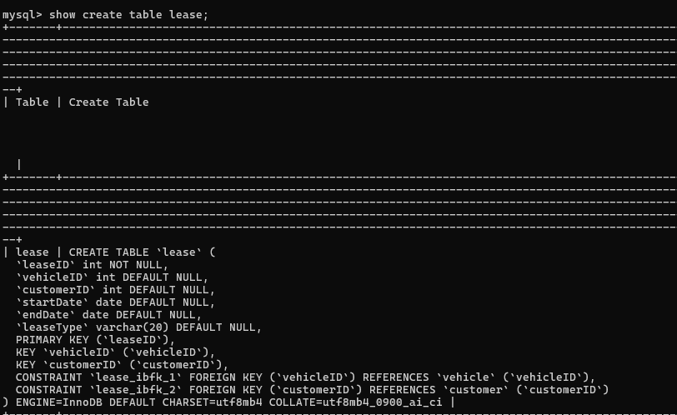



Now for the payment table:





Now showing the result:

**Q3- Query to rename the "paymentDate" column in the Payment table to "transactionDate".**

Ans: Use “alter table payment rename column paymentDate to transactionDate”

**Q4- Query to find a specific customer by email.**

Ans: Use “select * from customer where email= 'sarah@example.com';”

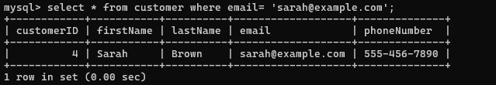

**Q5- Query to get active leases for a specific customer.**

Ans: In this there was no active lease of any customer.

I used “select * from lease where customerId= 2 and endDate> curdate()”



**Q6- Query to find all payments made by a customer with a specific phone number.**

Ans: Use “select p.* from payment p join lease l on p.leaseID= l.leaseID join customer c on c.customerID= l.customerID where c.phonenumber= '555-432-1098';”

**Q7- Query to calculate the average daily rate of all available cars.**

Ans: Use “select avg(dailyRate) as averagedailyrate from vehicle where status = 'available';”

**Q8- Query to find the car with the highest daily rate.**

Ans: Use “select make, model from vehicle where dailyRate= (select max(dailyRate) from vehicle);”

**Q9- Query to retrieve all cars leased by a specific customer.**

Ans: Use “select v.* from vehicle v join lease l on v.vehicleID= l.vehicleID where l.customerID= 3;”

**Q10- Query to find the details of the most recent lease.**

Ans: Use “select * from lease order by startdate desc limit 1;”

**Q11- Query to list all payments made in the year 2023.**

Ans: Use “select * from payment where year(transactiondate)= 2023;”

**Q12- Query to retrieve customers who have not made any payments.**

Ans: Use “select * from customer c where c.customerID NOT IN( select l.customerID from lease l join payment p on l.le

aseID= p.leaseID);”

**Q13- Query to retrieve Car Details and Their Total Payments.**

Ans: Use “select v.vehicleID, v.make,v.model, sum(p.amount) as totalpayments from vehicle v join lease l on v.vehicle

ID= l.vehicleID join payment p on l.leaseID= p.leaseID group by v.vehicleID, v.make, v.model;”

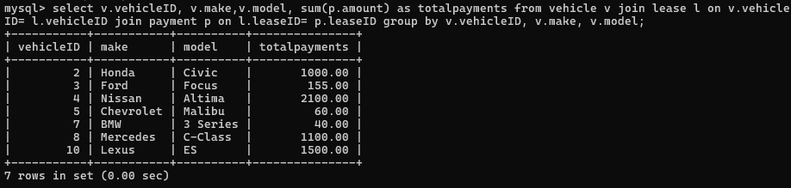

**Q14- Query to calculate Total Payments for Each Customer.**

Ans: Use “select c.customerID, c.firstname, c.lastname, sum(p.amount) from customer c join lease l on c.customerID= l

.customerID join payment p on p.leaseID= l.leaseID group by c.customerID, c.firstname, c.lastname;”

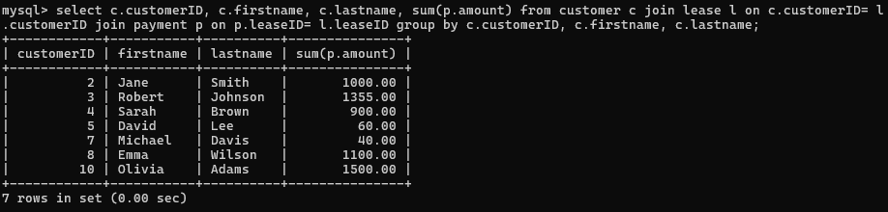

Q**15- Query to list car details for each lease.**

Ans: Use “select v.* from vehicle v join lease l on l.vehicleID= v.vehicleID;”

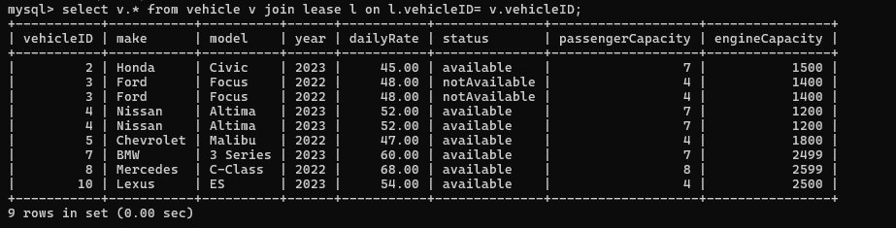

**Q16- Retrieve details of active leases with customer and car information.**

Ans: Use “select l.leaseID, l.startDate, l.endDate, c.firstname, c.lastname, v.make, v.model from lease l join custom

er c on l.customerID= c.customerID join vehicle v on l.vehicleID= v.vehicleID where l.endDate >=curDate();”



**Q17- Query to find the Customer Who Has Spent the Most on Leases.**

Ans: Use “select c.customerId, c.firstname, c.lastname, sum(p.amount) as totalspent from customer c join lease l on c.customerID= l.customerID join payment p on l.leaseID= p.leaseID group by c.customerID, c.firstName, c.lastName order by totalSpent desc limit 1;”

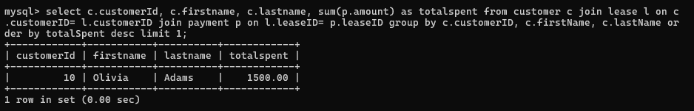

**Q18- Query to list All Cars with Their Current Lease Information.**

Ans: Use “select v.vehicleID, v.make,v.model,v.year, l.leaseID, l.customerID, l.startDate, l.endDate, l.leaseType fro

m vehicle v left join lease l on v.vehicleID = l.vehicleID;”

